Build and run the program with the original library function

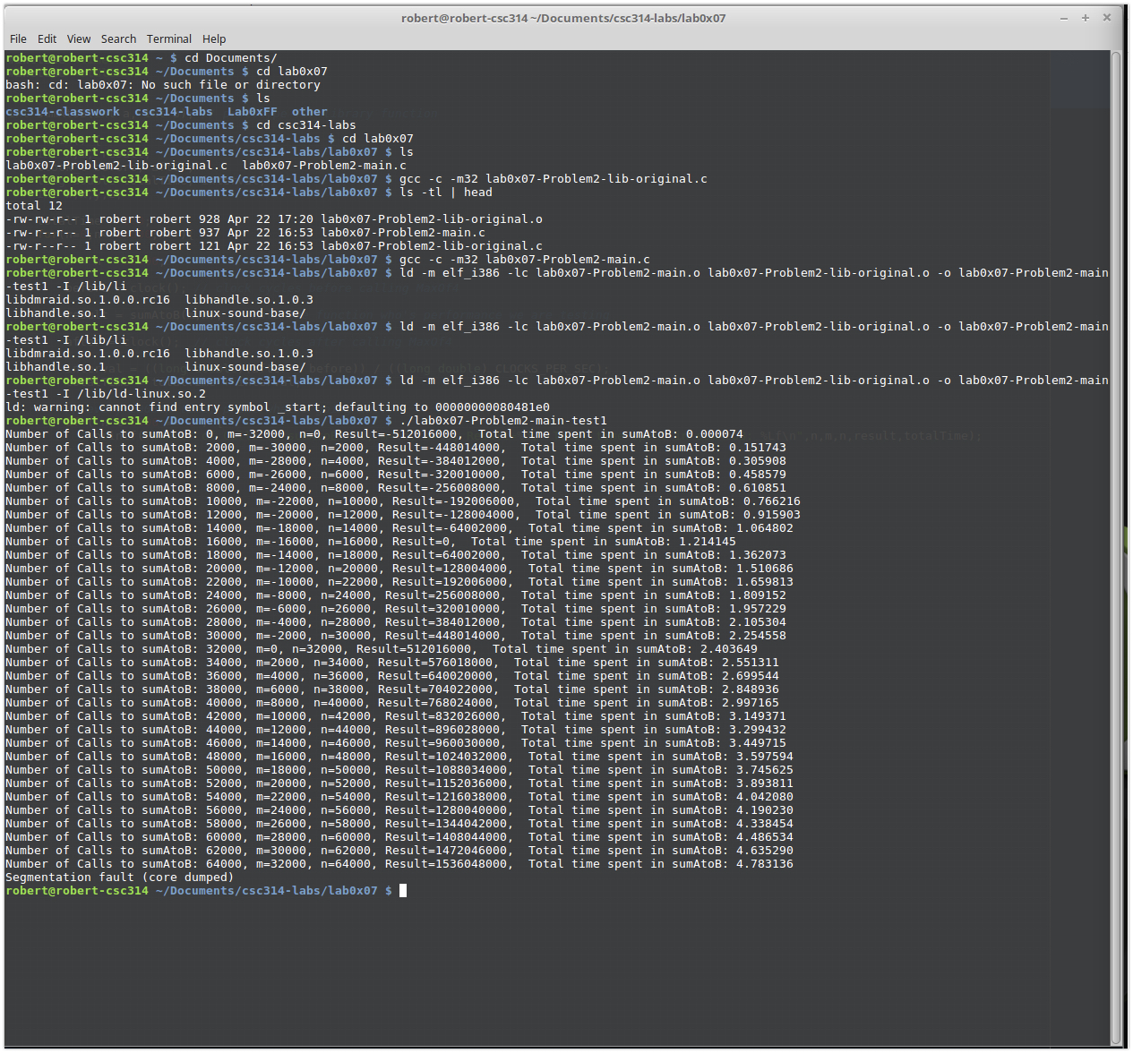

Building and running the original library a section time

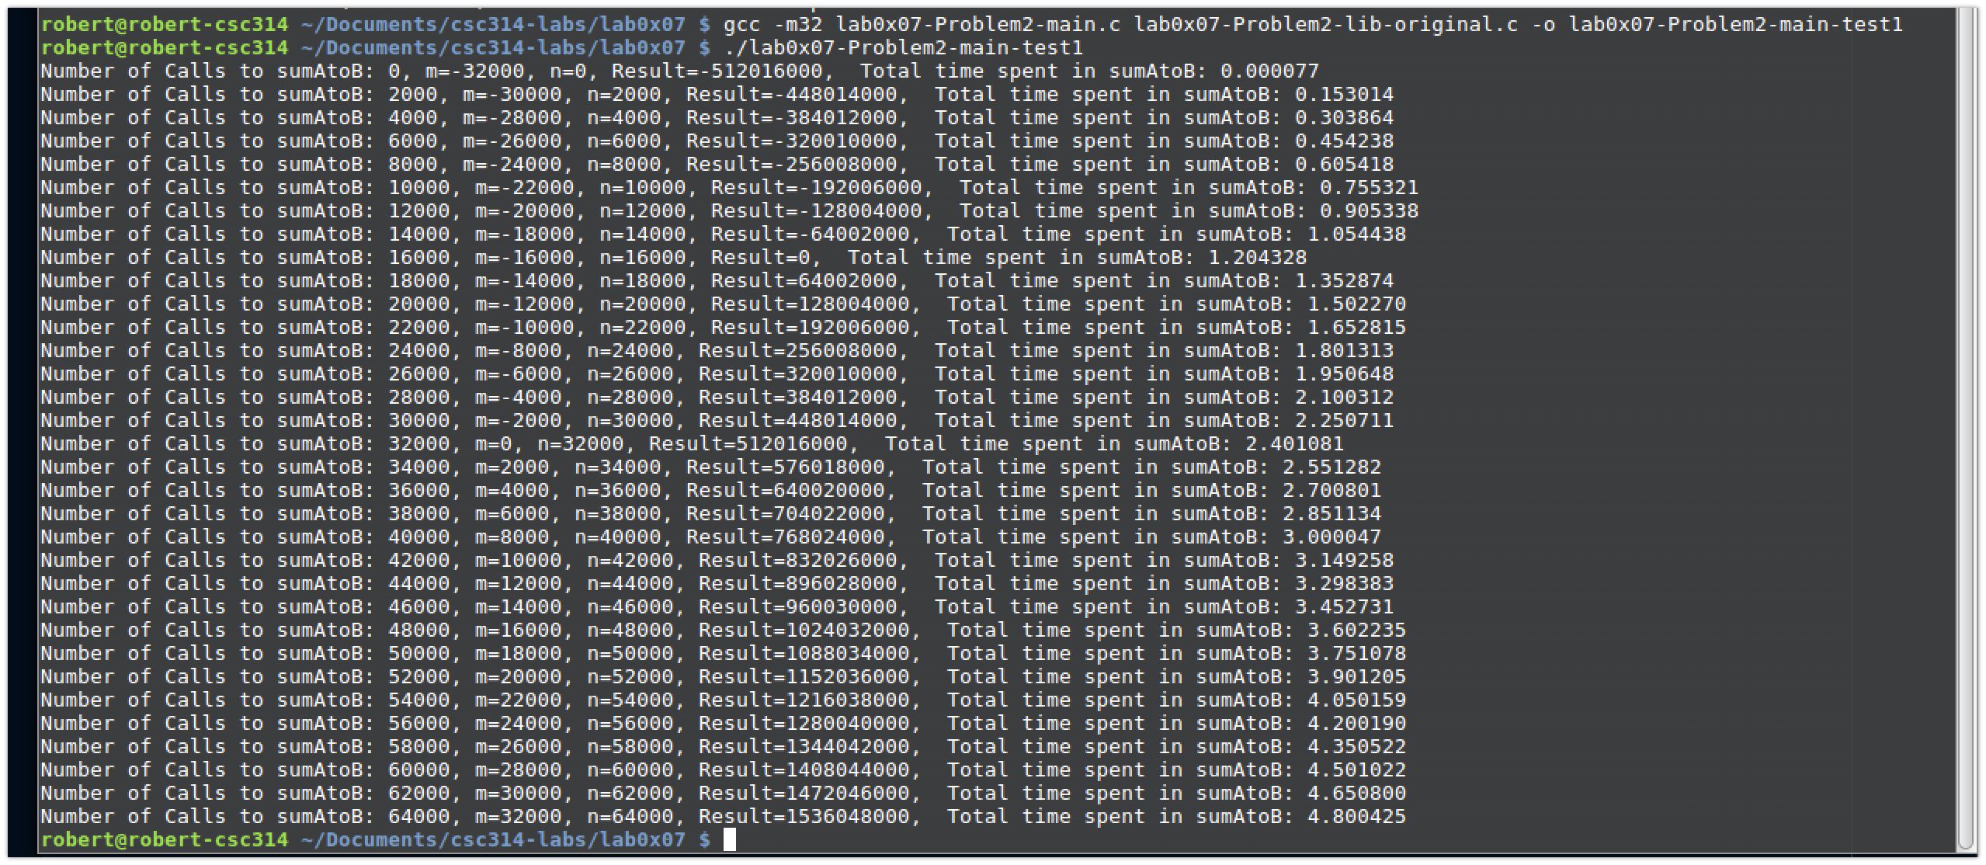

Disassemble the library object file with the linux command objdump

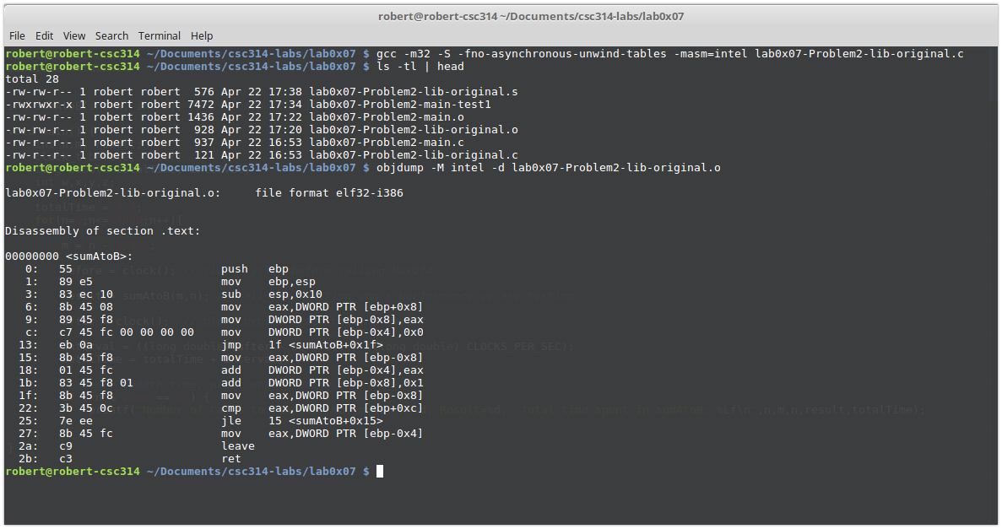

Used gcc command options to generate a “.s” file from the original library file

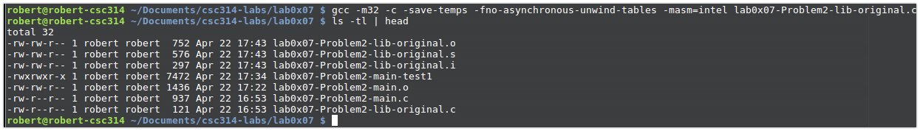

Testing versions of the modified library file

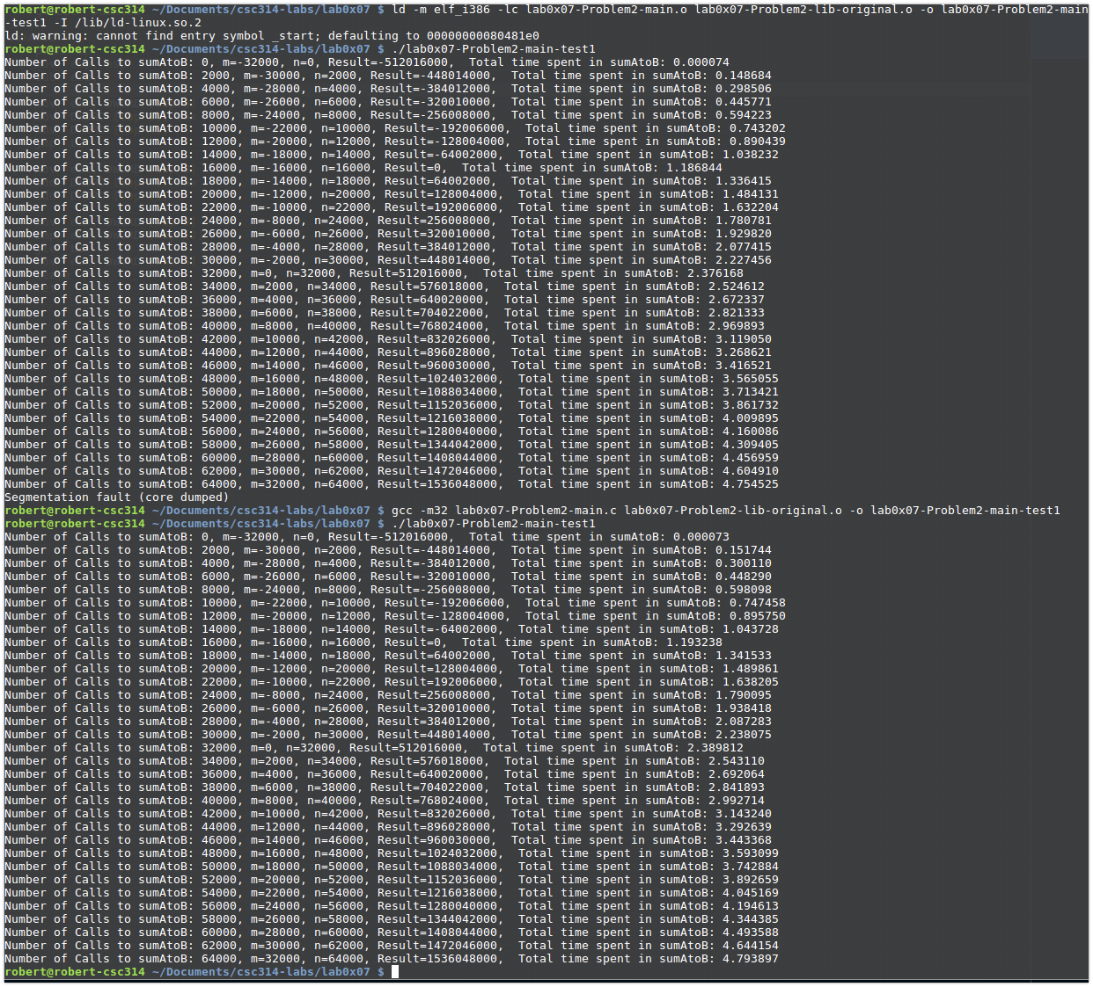

Run the final drafts of the tweaked library file

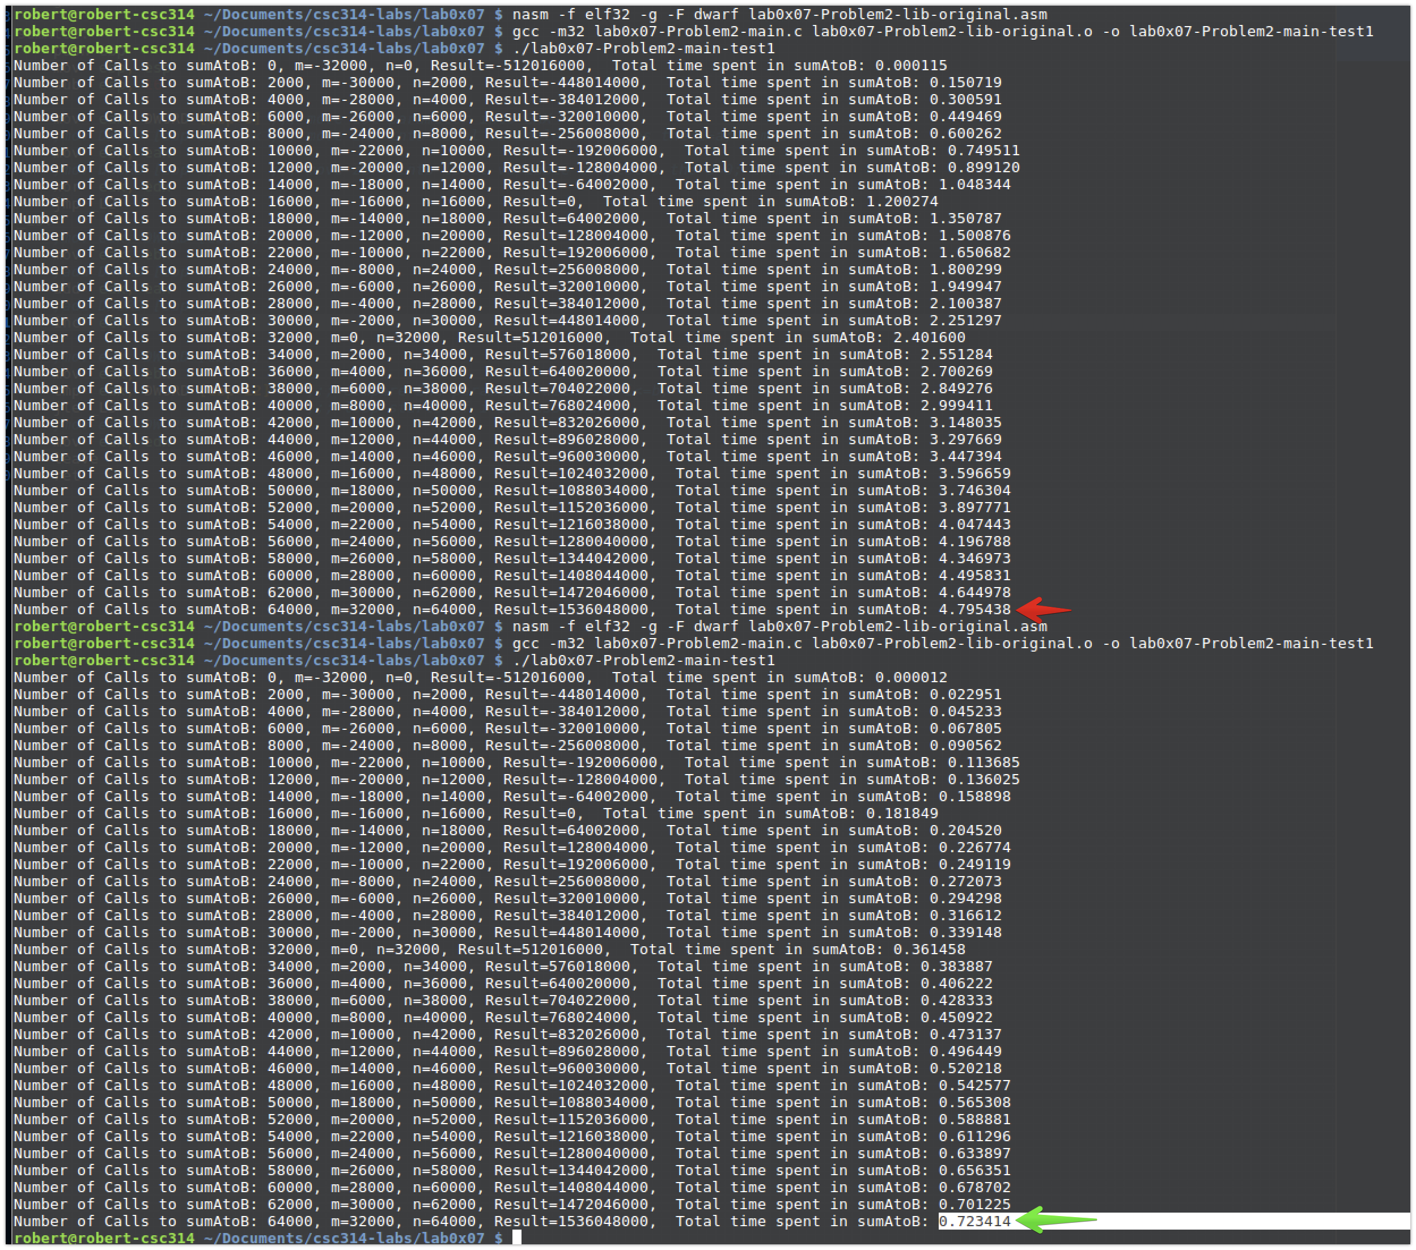

Running the final tweaked version of the library file with arrows pointing at the total times

